ADMISSION PROCESS
2024-2025 ACADEMIC YEAR

APPLICATION FOR ADMISSION TO GRADUATE STUDY

Submit a complete application form including all required documents as instructed below. Incomplete applications will automatically be rejected. Completed applications can be submitted by email: master_admission@ufar.am

Deadlines of submission:

From March 15-30, 2024 (1st admission), with a 15% reduction in tuition fee of the 1st semester.

From June 1-30, 2024 (2nd admission)
From July 20-August 05, 2024, (3rd admission, depending on available places)

Applications submitted after the set deadlines will be deemed ineligible.

Minimum entry requirements

Mandatory documents to accompany the application form

- A bachelor degree or equivalent (180 ECTS or 240 ECTS) in a French, Armenian or foreign HEI with the specialization of the requested Master or at least 3 years of experience if the requested master differs from the awarded degree. Both the diploma and the transcript need to be presented.
- English language proficiency test scores1:
  - IELTS Academic: minimum 6,5 with no individual band score lower than 6,0
  - TOEFL minimum 79 with no individual band score lower than 19
  - Cambridge Assessment English FCE (the FCE for Schools will not be accepted)
  - Cambridge Assessment English BEC Higher
  - Cambridge Assessment English CAE
  - Cambridge Assessment English CPE
- Letter of Motivation (in English)
- CV in English (Europass format)
- The invoice/payment slip of the administrative fee (25,000 drams). This amount is deductible from tuition fees in the event of admission, but non-refundable in the event of withdrawal or non-admission.

1 The validity of IELTS and TOEFL certificates is two years from the date the certificates were issued.

Requisites for administrative fee payment
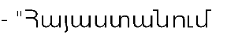
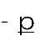
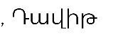
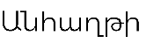
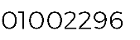
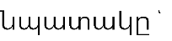
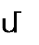
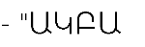
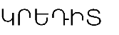
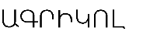
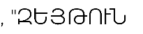
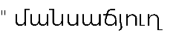
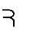
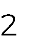
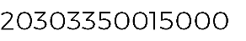

The admission procedures are as follows:

- submission of complete application,
- review of the application by the committee comprised of the dean of the Faculty of Informatics and Applied Mathematics of UFAR, the Associate Dean (or an authorized member acting on his behalf) of University Toulouse III Paul Sabatier, chair heads and other internal stakeholders as deemed necessary,
- admission interview and additional examinations if necessary, resulting in validating or invalidating the application.

Important provisions
- No applications will be accepted beyond the deadlines set by UFAR.
- Incomplete applications will not be processed.
- Admitted external candidates cannot be eligible for a merit-based scholarship for the first year. Admitted internal candidates can be eligible for a merit- based scholarship for the first year.

Further information

- For any information regarding the academic program please email Kristina Sargsyan-the Dean of the Faculty of Informatics and Applied Mathematics at respch_ima@ufar.am
- For any questions regarding the admission process please email us at master_admission@ufar.am

